advances
Erasmus Mundus MA Advanced Development in Social Work 2.0

Information – Guest lecturers

Once completed, please send this application form along with a CV (free-style application) to info-advances@aau.dk

There is no need to send references or proof of qualifications/skills/employment at the initial application stage, but these may be requested at a later stage.
Applicants will receive feedback from the board no later than two months after the above mentioned deadlines.

An informal telephone or Skype conversation may be held with relevant teaching teams to discuss activities and fit between applicant experiences and the programme. Unfortunately, ADVANCES cannot support all interested applicants in the programme. You will receive the note from consortium on final decision.

First name
Surname
Email address
Telephone number(s) (including country code)
Skype login (if available)
Job title(s)
Educational background
Place of work (institution name and full address)
Nationality (incl. multiple nationalities if applicable)
Preferred duration of visit (in weeks) | Please note: ADVANCES guest lecturers can spend a minimum of one week and a maximum of two weeks in one of the Consortium’s partner universities.

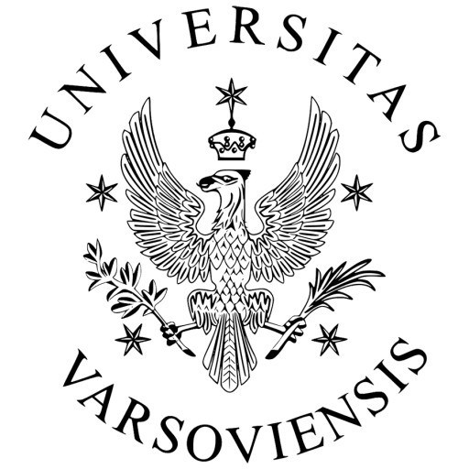
Please give an outline of your teaching and practice interests in social work (up to 350 words)

Please tick the modules or teaching activities in which you would like to be involved in
Nanterre, France (Summer 2023)
Details at https://www.socialworkadvances.aau.dk/courses-curriculum/Summerschool/
Summer School: Innovations in the field of social intervention

Lisbon, Portugal – Semester 3 (Autumn 2023)
Details at https://www.socialworkadvances.aau.dk/courses-curriculum/Semester+3/
Social Work Practice in a Global Context |  | Social Work Project Planning and Management
Ecological Social Work and Sustainable Development |  | Research Design and Planning
Social Responsibility and Entrepreneurship

Which month(s) or periods are you available to be a guest lecturer?

Are there any additional workshops, classes or other teaching activities about social work that you could offer during your time as guest lecturer?

For non-native speakers of English, please briefly list your experience of teaching, research and/or practice in English language

If applicable, please give details of current visas that you hold for the proposed location as guest lecturer

Thank you for filling out this form

